Bulletin Autumn 2012

The Twin Pillars of the Derbyshire Miners

Chesterfield Football Club played its final fixture on its old ground at Saltergate on 8th May 2010. The ground had been its home for 139 years. Crowds of supporters had traditionally made their way from the town centre along the road whose name the ground became known by. Less than two hundred yards before the supporters reached their destination, they passed two imposing statues standing outside the offices built for the Derbyshire Miners. These were first unveiled in 1915. As the statues are of two key former local miners' leaders, they formed part of the heritage of the crowds that walked past them. For, until the local pits went into their final decline in the 1980s, a high proportion of the club's supporters were themselves Derbyshire Miners.
The statues are those of James Haslam and William Edwin Harvey. They shared many common characteristics. They were born in the mid-19th century and were the youngest children in large and impoverished families. They started work at 10 years of age at local pits. Both became committed primitive methodists and also activists in their local miners' lodges. After minimal schooling, it was the Chapel and the Union through which they picked-up their education. They initially became involved with the South Yorkshire Miners' Association (SYMA), before helping to found the breakaway Derbyshire Miners' Association (DMA). They both became local magistrates and Chesterfield Borough Councillors; whilst

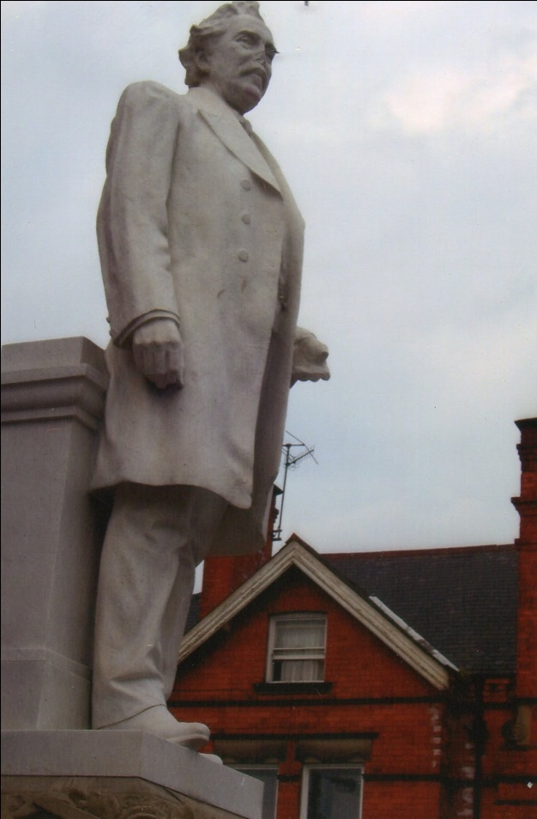

later they were elected to Parliament for local and neighbouring parliamentary
seats. They started out as Liberals (being known as Lib-Labs) and then together switched to the Labour Party. From 1890 to 1911 they shared the DMA's position on the Executive committee of the Miners' Federation of Great Britain (MFGB), often
taking turns each year in that position. They were both centrally involved in the work of the Trade Union Congress (TUC). They even died within nine months of each other. Their two statues were unveiled together a year after the death of Harvey, the short-term survivor. Appropriately, they were known as the “Twin Pillars of the DMA”.
The main differences between the two arose from the fact that Haslam was born in 1842, ten years before Harvey. As the older man, Haslam was always seen as the senior figure. He became a borough councillor two years before Harvey and then an MP just a year before his “twin”. Haslam became the first Secretary of the DMA, a position he held until his death. In the meantime, Harvey moved from Treasurer, to Assistant Secretary and then Financial and Corresponding Secretary. It was only for the short spell remaining after Haslam's death that Harvey inherited the top position in the DMA. Harvey was, however, a more extrovert character, being a renowned local cricketer and a passionate local preacher he was more ready to make speeches in the House of Commons than Haslam was.

Life histories

Disraeli's “Sybil : or Two Nations” and Engel's “The Condition of the Working Class in England” were first published in 1845. From differing political perspectives, they described the harsh conditions which working class people then experienced, including those in coal mining areas. It was such a pattern of life that Haslam had been born into in Clay Cross which is six miles south of Chesterfield, just three years before Disraeli's and Engels' books appeared. He was the youngest of ten children. His father was a shoe maker. At ten years of age, Haslam went to work at the local pit brow, working a twelve hour shift. The idea that he would become an MP, would never have entered his head. For he lived in a parliamentary constituency that was not for people like himself to represent. It was a two-seater covering the whole of the northern half of Derbyshire, which was shared-out amongst those with major landed interests. Electoral contests seldom took place, as deals were struck within the landed aristocracy. One of the seats (which had operated under even wider boundaries before 1832) had been held by members of the Duke of Devonshire's family continuously since 1734. Less than 3,000 men were qualified to vote and there was no secret ballot. The Cavendish family of the Dukes of Devonshire were based in a stately home at Chatsworth, ten miles east of Chesterfield. It was a different world from the one inhabited by Haslam. But in 1858, he moved from the pit brow down to the mine itself. Then in 1875, he became Secretary of the Clay Cross Lodge of the SYMA. The life he had entered upon would come to reshape his horizons.
Harvey was born in Hasland, at the southern end of Chesterfield. He was the youngest of five children. His father, who had been a labourer, died when he was a child. His mother then made what living she could by baking bread. At ten, he started work at a pit in Grassmoor, involving a hefty walk to work for a youngster, on top of his long shift. At 17 he joined the Hasland Lodge of the SYMA after hearing a lecture on trade unions. At 21, he was elected as delegate to Area Council Meetings which were held in Barnsley, over 20 miles north. This led to his dismissal from work and blacklisting. He then moved to different pits in the Chesterfield area, but he continued to suffer from sackings due to his trade union activities.

Miners’ unions in Derbyshire

In the above period, the main unions seeking to cater for miners in North Derbyshire were the SYMA founded in 1858 and the Derbyshire and Nottinghamshire Miners’ Association which emerged in two stages in 1865 and 1872. Whilst the SYMA became the more prominent, so did growing discontent over its operations. It was not easy for Harvey and other delegates to get to its Council Meetings in Barnsley and it came to be seen as concentrating its efforts on the well-being of miners in South Yorkshire. When Haslam took over as Secretary of the Clay Cross Lodge, its membership was in decline from 560 the previous year to 350. In the following four years it collapsed to only 17 members. Haslam blamed the lack of central support, the SYMA having rejected demands to set up a North Derbyshire Panel. In 1880, the Derbyshire Times reported that moves were progressing to set up a separate association for Derbyshire. By then Haslam had resigned as Lodge Secretary and was at the centre of the move. Harvey later claimed that the key meeting to establish the DMA was held at the old Sun Inn in Chesterfield (only 300 yards south of Saltergate) when five miners met to draw up plans. These were Haslam who became Secretary, Harvey the Treasurer and Bunting the President; with Smith and Catchpole becoming Committee members and Auditors. Initially, Haslam was unpaid and ran the Association from his home. But the DMA expanded rapidly. It recorded a membership of 616 in 1881, just a year after the move to set it up. A decade later, it had a membership of 18,728 and by the time of Haslam's death in 1913 it had passed the 40,000 mark. Its lodges had reached 60 by 1890 and 90 by 1908. Initially the meetings of its Executive and Council were held in the old Sun Inn, but as the Area Council grew in size it moved to the Falcon Temperance Cafe, nearby on Low Pavements: a move in keeping with Haslam and Harvey's” Primitive Methodist” views on the evils of drink. Then in 1893, only thirteen years after the first small meeting to establish the DMA, it moved into its own new substantial building on Saltergate.
Haslam and Harvey were quickly involved in mining issues at a national and international level. The DMA had early links with the Miners' National Union (MNU), both attending Conferences at Manchester and Birmingham in 1893 to discuss restrictions on output. By 1890, they were representing the DMA at the first International Miners Conference in Belgium, with Harvey making an impression with an impassioned speech supporting German miners who had been stopped from attending by their government. The following year the International Conference was held in Paris and Haslam led the main debate seeking an international strike by miners in support of an eight hour day. Yet more cautious approaches to political and industrial action were normally being expressed by both men.They were not enthusiastic about the decision of the DMA to move away from involvement with the MNU in 1890 and to join the MFGB. They were worried that the MFGB (the forerunner of the NUM) would be given to militant tactics and to the expression of socialist aspirations. They had come to believe in responsible trade unionism in the Lib-Lab tradition and were not later attracted by moves to set up the Independent Labour Party (ILP) in 1893 and then the Labour Representation Committee (LRC) in 1900, the latter being the early version of the Labour Party.

Political representation

To meet the growing influence of an increasingly well-organised work-force, the coal owners set up their own regional and national organisations. Alfred Barnes, described as the “Father of the Derbyshire Coalfield”, played a leading role at both of these levels. He also ran the pit at Grassmoor where Harvey had started work and he presided over the Derbyshire, Nottinghamshire and Leicestershire Coal Owners’ Association. Barnes helped to establish the Miners’ Association of Great Britain , which he presided over in 1881 and 1888. At local, regional and national levels, he was regularly in negotiation with Haslam and Harvey. Yet all three also rubbed shoulders in the local Liberal Association, with Barnes becoming the Liberal MP for East Derbyshire from 1880 to 1885 and then, under the redistribution of seats, the Liberal for Chesterfield from 1885 to1886. The three of them were also local magistrates. But clear divisions took place between their two camps. In opposition to Gladstone's support for Home Rule in Ireland, Barnes defected to the Liberal Unionists, for whom he held the Chesterfield seat from 1886 to 1892. Then followed the bitter mining lock-out of 1893, with Barnes firmly on the other side of the fence to Haslam and Harvey. Following a fall in coal prices, the coal owners demanded a 25% cut in wages. The lock-out in MFGB areas, including the territory covered by the DMA, persisted for almost four months, producing considerable distress and numbers of violent incidents. Eventually the Foreign Secretary, Lord Rosebery, drew the two sides together and a compromise was reached. The old wage rate was re-established until the following February and a Board of Conciliation was established to determine future rates. The strike had created a coal shortage, which had pushed up price.
Parliamentary representation came to be seen as important for mining trade unions. Legislation was needed to ensure that miners were not cheated over payments for the amount of coal they produced, to improve safety conditions, to end the employment of boys, to seek minimum wages, to set up conciliation procedures and to regulate the powers of the coal owners. There was also a deep need to improve housing, education, health and social provisions for miners and their families.
Three of the legislative impediments to miners entering Parliament were removed in 1872, 1884 and 1885. First, the secret ballot was introduced so that when miners finally got the vote, the coal owners would not be able to intimidate them over its use.
Secondly, the franchise was extended so that for the first time a good proportion of miners as householders could qualify to vote, plus £10 lodgers. Finally, parliamentary seats were re-distributed adding to the numbers available in mining
areas.

Labour representation

Immediately the above reforms were completed, Haslam stood for parliament in Chesterfield as Independent Labour. Although he finished at the bottom of the poll in a three cornered contest against Liberal and Conservative candidates he polled 1,907 votes, over 25% of the turnout. At the time the DMA only had an estimated membership of 2,000, many of whom lived in neighbouring constituencies, especially in North East Derbyshire which was a heavy coal mining area. Nor did all miners qualify to vote, including those those who lived with their parents. On top of this the DMA had not yet had time to ensure that newly enfranchised miners were all registered to vote. Haslam also challenged the two dominant parties. The successful candidate was Alfred Barnes.
An extra problem facing Haslam's parliamentary ambitions was finance. Elections were expensive and MPs weren't paid and needed to meet travel and London accommodation costs. In 1886 the Irish issue led to another General Election, with Barnes defecting to the Liberal Unionists. Haslam then sought the Liberal nomination with its financial backing, only losing the vote for the candidature by 41 to 35. It was Thomas Bayley, a Nottinghamshire coal owner who won the nomination. But as a fellow Gladstonian Liberal, Haslam found him acceptable. Bayley later went on to represent Chesterfield from 1892 to 1906, unchallenged in any way by Haslam. It was only when Bayley stood down in 1906 that Haslam stood in his place as a Lib-Lab with the backing of both the DMA and the local Liberal Association.
Thomas Bolton, a Director of the Rhymney Coal and Iron Company in Wales, held the neighbouring North East Derbyshire seat from 1886 until he retired from ill health in 1907. Despite his coal interests, he worked closely with the DMA; providing free conveyancing over the building of the Derbyshire Miners' Offices, pressing DMA concerns in the Commons and addressing their annual demonstrations. When he retired, Harvey stood successfully in his place, on the same Lib-Lab basis as Haslam.

Affiliation to the Labour Party

In 1908 when the MFGB moved to affiliate to the Labour Party, the vote in the DMA was over three to one against the move. At the 1909 Conference of the MFGB, Haslam moved that as only half of the national membership had voted in favour of the affiliation, a fresh ballot should be held requiring a two-thirds majority before affiliation could take place. But the move was defeated by four to one. When the MFGB then joined the Labour Party, Haslam and Harvey loyally moved into the Parliamentary Labour Party along with another dozen mining MPs. In the two General Elections of 1910, they both stood successfully as Labour candidates, with the Liberals offering no opposition.
There was a political ambiguity about the 4 and 5 year periods in which Haslam and Harvey operated as Labour MPs, for ideologically they were still liberal collectivists. But this created few problems for them as it wasn't until 1918 that Labour tightened up on its structure and on its own general ideological stance. Yet both Haslam and Harvey had died before the start of the First World War. Then just as they had both come to make use of avenues they had not sought in the MFGB and the TUC, so they also operated within the Labour Party. At the close of 1910, Harvey expressed his double edged approach, saying “Who is afraid of socialism? I am not. I believe that the common sense of this country would regulate socialism”.
A major dispute engulfed the coal industry whilst Haslam and Harvey were Labour MPs. Miners who produced coal in poor and abnormal conditions were often placed in difficulties as they could not produce sufficient coal to provide a normal wage. Trouble developed around the issue in Wales in 1911. It was a matter which created problems for Haslam and Harvey. The MFGB sent Harvey and Ashton its Secretary to seek to settle the dispute in Wales, but they weren't successful. Harvey was condemned by the South Wales Miners for making what they saw as a false claim when he said that they had acted contrary to their rules. Then later at an MFGB Conference, Haslam called the Welsh miners a “wild howling mob”. He was forced to withdraw his remarks. The dispute over abnormal working conditions developed into a demand by the MFGB for a minimum wage which led to a six week national strike, which resulted in the passing of the Coal Mines (Minimum Wage) Act, with a system of District Boards operating the measure. It was not, however, the pattern which the MFGB had favoured. Whilst Haslam and Harvey had cautioned against militant action on the issue, the DMA membership had voted heavily in support of the strike action. As often, the pair were pushed into actions, which they then sought to deliver upon. When asked once why he had changed his opinions to please his followers, Haslam replied “I am their leader you know, and I must follow the people”.

If Haslam and Harvey had at times to be pushed into radical positions it should be noted that, more than anyone, they had set up and built the DMA. They worked assiduously on its behalf via the national bodies it affiliated to, even though these developments often took place against their wishes. Their basic views were formulated in an era before the birth of the ILP and the Labour Party. Yet they built bridges which many of their successors used to further the interests of the established labour movement. In North East Derbyshire, four subsequent Labour MPs emerged from the DMA and served in the Commons for a total of 61 years. In all eleven Labour MPs emerged locally from the DMA, including today's Dennis Skinner their former President. Effective and dedicated DMA officials also emerged, such as Bert Wynn and Peter Heathfield. On 26 June 1915, a huge crowd of miners and their families crammed into Saltergate in front of the Miners' Ofices to see the unveiling of the statues of the two men who had meant so much to them.

Note : The main primary sources on Haslam and Harvey are held in the local studies section of the public library in Chesterfield. The key secondary source is pages 126 to 513 of “The Derbyshire Miners” by J.E.Williams (George Allen and Unwin, 1962).

Harry Barnes.

Labour Heritage AGM

This was held at the Bishopsgate Institue on Saturday 17th March. It was attended by over 30 members. We had two talks from committee members of Labour Heritage, the first of which was a commemoration of the organisation’s thirtieth year.

Thirty Years of Labour Heritage

Barbara Humphries provided a concise history of Labour Heritage – of which she has been a member since 1995, having coming across an item about it in Labour Party News.
At the time of Labour Heritage being founded in 1982, the Tories under Margaret Thatcher had been in government for three years – but the Labour Party was high in the opinion polls. Barbara paid tribute to the founding members of Labour Heritage, in particular Stephen Bird who had previously been the archivist for the Labour Party [these archives were moved to the People’s History Museum in Salford] and Irene Wagner, who had been a Labour Party librarian. In the early years of Labour Heritage, Irene had produced alongside the main Bulletin, a number of Women’s Bulletins, which carried material especially focussed on women in the labour movement.
In “The making of the English working class” E.P. Thompson had transformed what we thought of as labour history, to a study of the grass roots of the labour movement, or “history from below”. From that time increasingly material was written by people active in the labour movement – rather than being purely the preserve of universities.
Labour Heritage shared this vision, and its main focus has been on recording local CLP and labour movement histories – this is in contrast to a number of other related organisations, in particular the ‘Society for the Study of Labour History’ which tends to operate in the academic sphere, and the ‘Socialist History Society’, which has a wider remit especially including the history of the Communist Party in the UK. The Labour Party Oral History Project was launched in the 1990s by members of Labour Heritage.
Barbara pointed out that heritage is not just about history – it is about celebrating the past, for example the achievements of the co-operative movement.

Labour in London – why the delay?

Stan Newens, chair of Labour Heritage, gave a talk on the theme of why the foundation of the labour movement was later in London than in many other parts of Britain. This was due to the lack, until the late 19th century, of an industrial working class. The birth of the working class with its distinct culture and politics, including trades unions, co-operatives, friendly societies, even choirs, brass bands and educational and sports activities occurred in many parts of the country in the early 19th century, as described by E.P. Thompson in his work “The making of the English working class”. Although London was the largest city in Britain, it did not go through this process. It was a commercial and financial centre. Its population consisted of clerks, shop-keepers, many semi-skilled and destitute immigrants, who like the Jews gravitated to it in the search for a livelihood. The 1846 Irish famine had led to a large migration to England. Many of these obtained only seasonal and casual employment. There were no large scale factories. In 1851, 86% of firms in London employed less than 10 workers, and only 12 employed 300 or more.
There was a labour aristocracy of skilled artisans – printers, for example, which produced support for radical political movements. These included known radicals such as Francis Place and William Lovett.
By the mid-19th century London was experiencing inner city decay as long established crafts such as silk weaving and ship building moved away from the capital. For example silk weaving employed 54,000 in 1824 and 3,000 in 1880. Boot making had moved to Leicester. By 1861 only five main industries remained in London. These included clothing, woodwork, printing and engineering. A lot of this was home-based, not large scale industry. But heavy engineering including ship building had moved out of London. Mechanisation of these industries was causing further decline in employment. The other main industry – the docks was highly casualised. 24,000 dockers competed every day for as little as 11,000 positions. On a good day typically only 17,000 would find work.
The Booth maps illustrate the extent of London’s overcrowded slums, or rookeries as they were called. Slum clearance in the 19th century was done to provide space for warehousing, thoroughfares such as Kingsway and the Strand, and the railways. 23,000 were displaced by railways in the early 20th century. Those made homeless had to find alternative accommodation without assistance.
These social and economic conditions affected political activity in London. The insecure rioted. This could be in support of reactionary or radical causes – Chartism or the Gordon riots. Labour movement organisations – such as trades unions, the co-operative movement and the Labour Party had got off to a slow start in London. The Independent Labour Party which had its roots in Bradford, had only 500 members in London in 1899. There was however support for the Co-operative movement from the Stratford railway workers, workers at the Woolwich Arsenal, and the Edmonton tram workers.

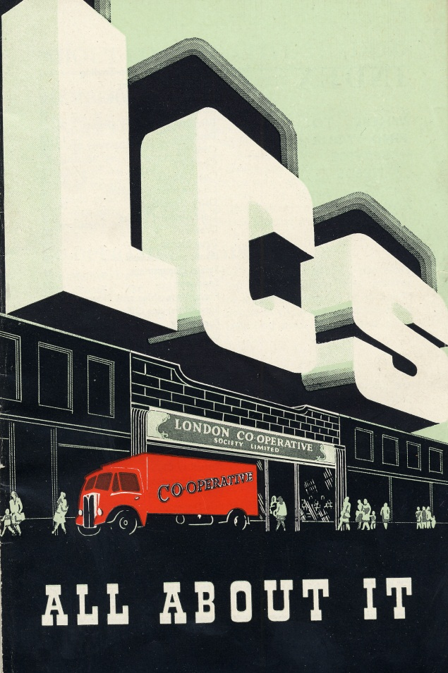

London Co-operative Society Archive, Bishopsgate Institute

There were exceptions to London’s backwardness. There were three labour strongholds – Battersea which was based on the local candleworks and produced activists such as John Burns, West Ham based on the docks and related industries and which elected Keir Hardie as the first Labour MP in 1892, and Woolwich, which was based on the Arsenal. All these three areas were at that time on the fringes of London – West Ham was regarded as part of Essex.
Change in London was not to come until after World War 1 with the development of new industrial areas in the suburbs of the capital. This included Park Royal in West London, which was to become one of the highest concentrations of industrial activity in Europe. There was also industrial development in Hackney and Dagenham.
As a result of its backwardness London had been a bastion of working class conservatism, with Labour making a limited impact. The London County Council, formed in 1899 was dominated by a Progressive Liberal Alliance. Of the 29 first Labour MPs in 1906, only three were from London. Trades unionism had however made its mark with the strikes of the dock workers in 1889, and the match workers at Bryant and May. There was a “co-operation desert” in London, dispite the efforts of individuals to set up co-operatives. Exceptions were the Stratford railwaymen and the Royal Arsenal Society. There was a socialist revival in the 1880s, resulting in the setting up of the Socialist League.
The 20th century was to see changing fortunes in Labour’s success in London. By 1919 there were 17 Labour representatives on the London County Council. A Labour council was elected in Poplar led by George Lansbury. The LCC was captured by Labour in 1934. Bethnal Green, however did not see its first Labour MP until after 1945.
Stan concluded that the de-industrialisation of London in the 19th century was similar to what we see in cities all over the world today. He gave the examples of Lagos, Mumbai and Calcutta. Populations of poor desperate people take to rioting as they had in London in the summer of 2011.
There was a short discussion on Stan’s
talk.

Visit to the Bishopsgate Institute

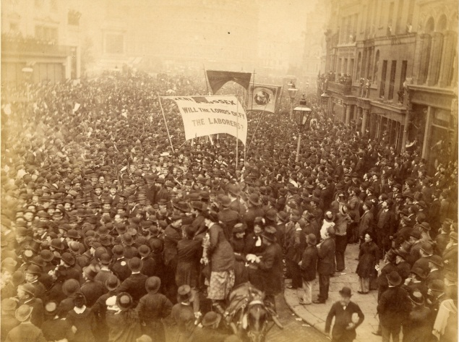

Great Reform Demonstration, July 1884
George Howell Archive, Bishopsgate Institute

As part of Labour Heritage’s 2012 AGM, held at the Bishopsgate Institute, we had the privilege of being taken round on a guided tour of the collections of the Institute by Library and Archives Manager Stefan Dickers. Stefan was well aware that we would be particularly interested in their unique labour history collection. The collection was started by George Howell. Howell served on the General Council of the International Working Men’s Association ( IMWA, the First International) and later was involved in the affairs of many British trade unions. Stefan suggested that George had a light fingered approach to collecting books and records of the organisations he was involved in. He certainly built up an unrivalled collection of material, which he donated to the Institute in 1905.
A star exhibit was the original hand-written minutes of the IWMA. These were suppressed for many years at the behest of a Tory member of the trustees and locked away in the strongbox of a bank from 1925, despite the insistent demands for publication from David Riazanov of the Marx-Engels Institute in Moscow. Finally Churchill contacted the Institute in 1941 after the Soviet Union entered the War and allowed the minutes to be copied and published as a friendly gesture to our allies.
The labour history collection has 11,000 books and pamphlets covering all sides of the movement. It also has unique archives, such as those of Bernie Grant MP. It also has the finest collection of Co-operative Society records in the south-east of England, the archive of many trade unions such as those of the Amalgamated Society of Engineers going back to the 1860s, and more recent contributions such as the archive of the National Miners’ Support Network and Dave Wetzel’s archive covering the Greater London Council in the 1980s and other recent struggles.
Stefan was an entertaining and informative guide, and made us aware of what a treasure house of labour movement material the Bishopsgate Institute holds.

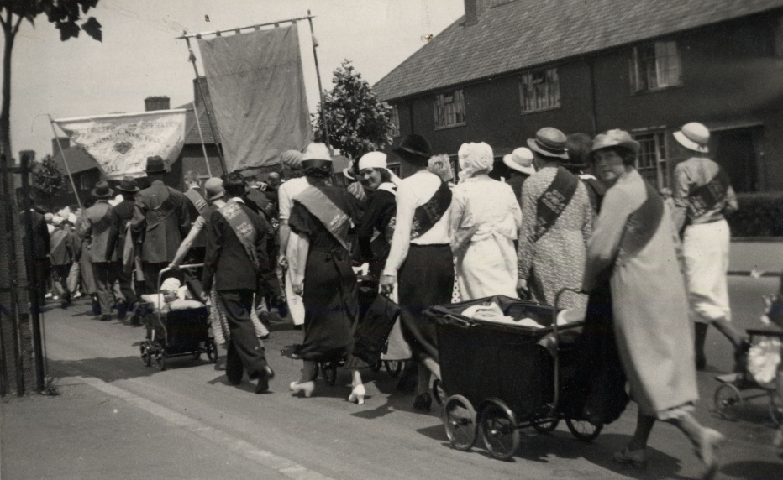

Womens’ Co-operative Guild march from the 1920s.
Womens’ Co-operative Guild Archive, Bishopsgate Institute

Book reviews

The Big Meeting: A History of the Durham Miners’ Gala
by David Temple, TUPS Books in partnership with the Durham Miners’ Association,hardback £19.50 + £4 p&p, paperback £14.50 + £3 p&p(Only available from Durham Miners’ Association: PO Box 6,
Red Hill, Durham, DH1 4BB dmapress@aol.com)

David Temple was an electrician at Murton Colliery in County Durham, Lodge Secretary of the union, and served on the Executive Committees of both the Durham Colliery Mechanics’ Association and the North East Area NUM. After the closure of Murton, in 1991, the National Coal Board gave him a job as pump man at Easington, working in an abandoned seam, away from fellow workers; victimisation for his role in resisting the closure of Murton.
A founder of Trade Union Printing Services and the author of four other books, he was asked by the Executive Committee of the Durham Miners’ Association to write the history of the Miners’ Gala. The result is this lucidly written, well produced and illustrated history of an institution which has been of not just regional, but national, and sometimes international, importance.
The first Durham Miners’ Gala or ‘Big Meeting’ was held in Wharton Park, Durham City on a warm summer day in 1871, and the second Gala of 1872 established the practices which continue to this day. In the words of the author ‘miners would converge from all directions and march through the old city streets to the County Hotel... Here they would be greeted by their leaders and guest speakers, who would wave to them from the hotel balcony as the bands and banners marched off, past the Shire Hall, the County Courts and the Prison, before dropping down to the racecourse’. The leaders and speakers then left the hotel by the rear entrance and walked to the racecourse where a speakers’ meeting was held.
Importantly, the speakers were not invited by the union executive but were selected by the miners’ lodges. This led to many tensions and battles, fought out on the stage of the Gala: struggles concerning the ‘old unionism’ of the Durham Miners’ Association leaders and the upstart ‘new unionism’ of speakers such as Tom Mann. Connected with this was the increasing attraction of socialism which threatened and finally overcame the loyalty to Liberalism shown by the old leaders.
The speeches are detailed throughout and the author makes good use of local newspaper reports. There is also a list of speakers from 1871 to 2011.
The choice of speakers is interesting and impressive. The militant atheist, Thomas Bradlaugh was a favourite, speaking on eleven occasions. This is intriguing, when one considers the strength of Methodism amongst the miners. The Anarchist, Prince Kropotkin, spoke in 1882. Labour Party leaders from Keir Hardie to Neil Kinnock addressed the crowds. In 1946, the Gala was attended by: the Prime Minister, Clement Attlee; the Chancellor of the Exchequer, Hugh Dalton; Aneurin Bevan, Minister for Health and Housing, and Jack Lawson, Minister for War. Also speaking at this Gala was the American Ambassador, Averell Harriman, who was soon to take charge of the American economic plan for the reconstruction of Europe, known as the Marshall Plan.
The importance of the proceedings is shown by the fact that the attendance of ambassadors became a feature of the Gala. The powerful post-war General Secretary of the Durham Miners’ Association, Sam Watson, was a strong friend of the new Israeli state (so much so that there is a room in the Knesset named after him). The Israeli Ambassador was, apparently, a regular invitee to the Gala until the 1980s.
As anyone who has attended will know, the lodge banners and bands are an important feature. The book includes nineteen pages of colour photographs of the banners and is illustrated throughout with portraits of the speakers and scenes of the Galas.

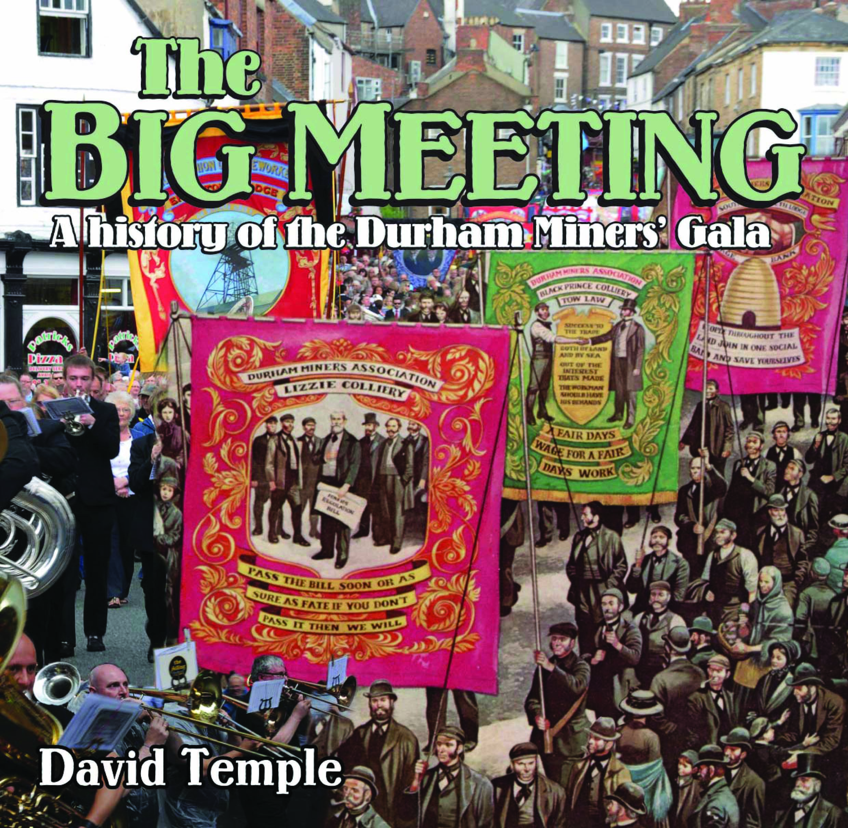

The Gala today

But what of the Miners’ Association and the Gala today? As Temple explains, the Durham miners’ union emerged from the 1984-5 strike with only £44,000 in liquid assets. Through skilful financial management, self-sacrifice and a lot of risk, the union devoted itself to pursuing test cases on the behalf of former miners who were suffering from vibration white finger and chronic bronchitis and emphysema. In this struggle they were successful.
When the last Durham pit closed, in 1994, many assumed the Gala would decline and die. However, it revived and thrived. A factor in its survival and further development was the open invitation, made in 1986, for all trade unions to participate. The participation of different unions, and particularly the public sector unions, is important today. Also, in 1993, a New Zealand businessman, Michael Watt, gave a financial grant to the union to ensure the Gala’s survival.
Of course, the strength and solidarity of the people of the North East has been crucial. While the mining communities have lost their pits, they still have common interests, not least of which is the need for meaningful work for their young people. These common interests give the Gala continued relevance as a political and social event.
Neil Kinnock’s last attendance was in 1989 and the succeeding leaders of the Labour Party all regarded an invitation as toxic. Tony Blair, the MP for Sedgefield, a former mining constituency, stopped acknowledging the invitations.
At the 126th Gala in 2010, a letter from David Miliband was read out, as was a letter from his brother Ed. Both promised to attend the next Gala if they were elected Leader of the Labour Party.
Temple’s book concludes with an account of the 2011 Gala. Ed Miliband was due to speak, but pulled out. He gave two reasons. The first of which were his heavy diary commitments. This was not a good excuse. The Gala is always held on the second Saturday in July and can be entered in to a diary a year in advance. The second reason was that Bob Crow was to be a speaker.
As David Temple writes, ‘a cursory glance of Gala speakers over the years shows that… leaders of the Labour Party were not so choosy about the company they kept. Ramsay McDonald spoke alongside the militant Irish socialist and co-founder of the Irish Citizens’ Army, Jim Larkin; the mild-mannered Clem Attlee and the notoriously right-wing Hugh Gaitskell appeared on numerous occasions with communist Arthur Horner; Harold Wilson saw no problem in sharing the platform with communist Will Paynter; and Neil Kinnock appeared alongside Arthur Scargill’.
The truth is probably that Ed Miliband and his advisors were more concerned to avoid offending the fickle group they now call ‘the squeezed middle’, previously known as ‘middle England’, than they were to give encouragement to the people of County Durham who had stayed loyal and who had elected a Labour MP for every seat.
His decision backfired. As Martin Wainwright, the Guardian’s northern editor, pointed out, it ‘upset party activists without especially impressing the middle ground, leaving the juggling act familiar to all Labour leaders in disarray’. Thankfully, Miliband seems to have realised the damage done, and on the 14th of July 2012, he addressed the Gala; the first Labour leader to do so in 23 years.
He was clearly nervous, and his day was evidently not without its discomforts. While Bob Crow was not a speaker, he was a guest. When Miliband finally emerged on to the balcony of the County Hotel, he did so from the opposite end to the RMT leader.
Crow and his union, for their part, were not about to be silenced. A light aircraft buzzed around, carrying an RMT banner in its wake: ‘NO CON-DEM CUTS, NO LABOUR CUTS’.
What must have been another uncomfortable moment came when two striking Spanish miners gave fiery speeches. Finishing with clenched fist salutes, they left the podium and shook Miliband by the hand. This left him looking a bit shell shocked.
His speech was cautious but generally well received. He said many of the right things. The crowds had turned out in large numbers, and he must have been impressed by the eighty banners and fifty bands which made up the procession. The presence of the Labour Leader made for a more optimistic mood than usual.
The 129th Gala is scheduled for 13th July 2013. In the words of Carlos Alfaro, one of the rescued Chilean copper miners, who spoke in 2011, ‘Viva la Gala!’

Kit Snape

David Clark, The Labour Movement in Westmorland, Lensden Publishing, 2012

How lovely to read a well-researched, fascinating book about one of our constituencies which, no matter how hard the work, seems never destined to fall into Labour's hands. For the story of good socialists, deep in beautiful, rural Britain, battling against all the odds, is as uplifting as the hard, industrial tales of many a heartland seat. And the story told, with affection and care, by a true Westmorlander, Lord Clark of Windermere.
His homework is impressive, through archives, newspapers, interviews, his recollection of delivering the Daily Herald on his paper round in the 1950s, and two quotes from his own dad. He even managed to unearth perhaps the only copy of a 1918 Board of Trade Gazetteer of Trade Union Branches, Trade Unions and co in the UK - invaluable resource material as it lists 1917 trade union branches by county and town.
Westmorland had Conservative MPs for 87 years until it fell to the Liberal Democrats in 2005, one particular family providing no fewer than 58 MPs and peers, their dominance of Cumberland and Westmorland politics ending only with the ejection of one of their hereditary number from their Lords in 1999.
In such a rural, sparse land, unions took time to establish, but then played a key role in the development of the party, assisted in the early years by a Fabian group (the 92nd local Society, set up in 1894 and, although not long-lasting, re-formed in 2012), Christian socialists, Quakers, ILPers and, in particular, an early Arts and Crafts movement, thanks largely to John Ruskin himself. Indeed, Labour's first county councillor, Rev Herbert Mills, also founded the back-to-the-land Starnthwaite "colony" (or commune), a somewhat utopian and finally unsuccessful alternative to the workhouse, to provide non-exploitative jobs for the unemployed.
Early visits from Keir Hardie and Tom Mann, linking trade unionism, church and socialism, helped found the Kendal Trades Council in 1895 and led to the election of the first working man to Kendal MBC in 1903.
An active suffrage movement maintained political activity and discourse during the First World War, building support for Labour and attracting recruits, as did the temperance movement and the Quakers with their anti-war and anti-conscription campaigns. Meanwhile the 1917 Corn Production Act, with its minimum wage and Agricultural Wages Board, boosted union recruitment.

Formation of the constituency party

Prospects looked good for Labour when, nationally, the party nationally replaced the Liberals as the second party, polling 22.2% to Lloyd George Liberals' 13.5% and Asquith Liberals 12.1% to become the official opposition. But it was to be a false new dawn and, for the next 90 years, Labour would struggle locally with the Liberals for second place behind the ubiquitous Conservatives. The Constituency Party was formed June 1924, in the wake of the formation of the first Labour Government, proceeding in short order, despite a hostile local press (and the Zinoviev letter nationally) to take 28.8% (7,242) to the Conservatives’ 17,935.
It’s first (and, sad to relate, only) woman parliamentary candidate won a very respectable 31.5% in 1935 but this was followed by the ups and downs ("despair and delights" in Clark's words) of the party's fortunes. The book details the plenitude activities, local government successes, May Days, socials, rambling, the Labour Hall, personalities and developments, including the 1945 establishment of Joan Littlewood's remarkable Theatre Workshop in Kendal.

But of Labour representation, only Tony Cunningham's time as the MEP, plus some sterling local councillors, are all that this band of committed, active members can boast.
If ever, in "safer" seats we are downhearted, we should read this to be reminded of real struggles. Meanwhile, for the Labour historian, David Clark provides a rich source of detail and narrative, deserving a place on all our bookshelves.

Lord Morris of Aberavon, Fifty Years in Politics and the Law, University of Wales Press, 2012

This is a delightful book by a longstanding and eminent Labour MP whose devotion to Wales, its people and its language enthuses every chapter. Morris, as a fluent Welsh speaker, was a vital mover behind greater use the language, its teaching in schools and the establishment of the Welsh language TV channel: S4C.
He was also perhaps the prime lobbyist for, and designer of, Welsh devolution, as Secretary of State for Wales 1974-79) building up the status of the Welsh Office staff and of its powers to be ready for handing over to an elected Assembly. He was therefore devastated, “dejected” in his words, by the first referendum's overwhelming defeat (thanks partly to Kinnock's opposition).
Despite having worked so hard to design the scheme, and to organise the Referendum to take place on St David's Day 1979, his wise TV response was "if you see an elephant on your doorstep, you know it's there". Exactly 20 years later, however, as Attorney General, he was present on 1 March 1999 for the opening of the Welsh Assembly, the accumulation of nearly 50 years' work.
Morris was not simply Welsh. He was – as one of his detractors claimed, but as he boasted – "the product of a rural subculture". He understood agriculture by background but became deeply embedded in the steel industry, Port Talbot being the mainstay of employment in his south Wales constituency. His 40 years as an MP gave him intimate knowledge of its constituents and their work, a constituency he describes as "town, valley communities and a foreshore".
As Minister of Transport under Barbara Castle, Morris helped introduce both the (to me) very welcome breath tests (reluctantly without random testing) and the 70 mph speed limit. This and other positions, provide relevant lessons for today’s ministers, particularly about the hard work, clarity and firmness of objectives, the legislative process, and relations with the civil service, outside experts and the party.

Kosovo

Perhaps, though, one of the most interesting chapters covers his experience, whilst Attorney General, over Kosovo, about which he remains clearly troubled, despite having supported its objectives, and which led to some whitening of his greying hair. Describing Blair as "ready to commit British troops with a frequency unparallelled in modern times", his major surprise was that Blair hardly consulted him – the government’s senior Law Officer – and never one-to-one. Indeed, he felt that "keeping in step" with the Americans "was far too often uppermost in the mind of the Prime Minister and his small circle of advisers in Number 10".
In broad terms, despite the absence of a UN mandate, Attorney General Morris was completely comfortable about need for military action (to prevent humanitarian disaster as Milosevic was putting the lives of thousands of Albanians in jeopardy) but needed to be sure the minimum force necessary was employed and to approve targets to ensure they "had direct and concrete military advantage", with minimal civilian casualties. To ensure international law was obeyed (and conscious of the potential for action in international courts), law officers had to agree each target for UK action. He was naturally relieved that, of the 440 air attacks, only 3 civilians died.
Towards end of the war, one Friday in late May (1999), Morris refused to agree a particular bombing target, despite personal pleas from the Secretary of State for Defence. Although he declines to go into detail (due to the on-going refusal to release Attorney General advice), it is clear that the request did not meet the legal requirements.
After the war, there was a Yugoslav application to the International Court of Justice in The Hague, which Morris defeated by showing that, as Yugoslavia was not a member, it could not initiate action. However, he somewhat regrets that the Court could therefore not go on to consider the second arm of his defence – the justifiable cause for military action on humanitarian grounds as he had set out the "overwhelming humanitarian disaster" occurring as Kosovo was "being emptied – brutally and methodically – of its ethnic Albanian population" with nearly half a million displaced people. Thus NATO's military action was "an exceptional measure to prevent an overwhelming humanitarian catastrophe". He would have welcomed the Court’s endorsement of this arm of his defence case and with it some help in establishing the ground rules more clearly.

John Morris, Lord Morris of Aberavon, is a humane, highly intelligent, canny, thoughtful and practical politician. There are some useful lessons for all of us in this autobiography.

David Lipsey, In the Corridors of Power, Biteback, 2012

I met David Lipsey on 4 August 1970 as we both started work, appointed by Giles Radice, in the GMWU research department. Today, all three of us sit in the House of Lords. Between times, these two intellectual men have published a number of elegant and insightful books, the latest being David's so called "autobiography". In fact, it is more of a wise, thoughtful, highly informed review of Labour and the unions' highs and lows from the mid- 60s to the present, during which time, whilst Giles toiled in the Commons, David was a player within the heart of the party or government or else a journalist reporting on the same. His position, akin to Chris Mullin's in the foothills, provides a slightly arms-length, and less power- and personality-driven, commentary from someone deeply committed (from the age of 11) to the party he still cherishes, warts and all.
After the GMWU, Lipsey became a "chocolate soldier" (political adviser) to Tony Crosland at Environment and subsequently at the Foreign and Commonwealth Office, before he moved to Number 10 until 1979. From then he was variously editor of New Society, deputy editor of two national papers, political editor of The Economist, a member of three government commissions and a non-executive on a host of panels and boards in the public/regulatory sector.

Three key phrases

He claims only to have written three key phrases as a speech writer: but what three! "the party's over", "winter of discontent" and, yes, "new Labour". Their phrase making – from a professional writer – and his position in the movement explain their salience. But the other dimension of his input, that of policy-making, is described, where his Crosland-inspired respect for hard intellectual graft as the basis of policy ranges over electoral reform, financial regulation, long-term care of the elderly, broadcasting to name but a few.
His fascination with greyhound racing and the "gee-gees" (as gambler, regulator and participant) may be inexplicable to some of us, but is clearly of great importance to him and, together with music, give a flavour of his more rounded personality and life.
The book is worth a read both by those curious about the life of a political insider, and by those wrestling with the next version of Crosland's Future of Socialism, as it draws on those 40+ years to ask why Lipsey's beloved equality seems so hard to achieve, and to re-examine past policy strengths and failures.

Does this make for comfortable reading for future politicians of the left? No.
Does he remain an optimist? Surprisingly, yes.

Reviews of “The labour movement in Westmorland”, “Fifty years in politics and the law” and “In the corridors of power” are written by Dianne Hayter

Tommy Sheridan, From Hero to Zero? A Political Biography/ Gregor Gall
Welsh Academic Press, 2012

Gregor Gall’s fascinating biography was published in early 2012, co-incidentally just a few months before a period of renewed press interest in Tommy Sheridan when Andy Coulson, former News of the World editor was charged with committing perjury – he had given evidence at Tommy Sheridan’s perjury trial in 2010, leading to Sheridan’s 3-year imprisonment.
Gall places the rise and fall of Tommy Sheridan in the context of Scottish politics and culture. In the forward, Gerry Hassan writes of Scotland being ‘defined for generations by a left politics, but increasingly in modern times it has done so without an active left, instead only …the folklore of a left.’ Sheridan emerges from this tradition; he is initially seen as an inspiration and then later is caught up in a cycle of self-destruction, which included revelations of his personal life seized upon by a hostile press. The detailed analysis of Sheridan’s rapid rise to power, his campaigning zeal and his often cavalier treatment of his socialist colleagues are untangled by Gregor Gall, in a manner which shows a measure of sympathy for Sheridan while maintaining a fair, not uncritical, approach.
It is interesting to read of Sheridan’s early life, and the inspiration of his mother Alice, a trade union activist in the Transport and General Workers Union (TGWU). Alice recalled [in an article in Scotland on Sunday] ‘she had read to the young Tommy, Keir Hardie’s biography at bedtime when he was four years old and taught him about the miners’ strike of the 1970s’. The thread of his mother’s influence continued with her encouraging him to go to university – where he studied politics and economics – and on his later campaigning. At university, he became active first in the Labour Party and then within Militant – and was involved with the formation of Scottish Militant Labour (SML) as an independent party.
His charismatic personality rapidly brought him to wide notice through the campaign against the Poll Tax, and in particular he took part in direct action to prevent ‘warrant sales’ – seizure of goods from non-payers in lieu of their Poll Tax bill – resulting in a 6-month prison sentence in 1992.

Scottish Militant Labour

While in prison, Sheridan was elected an SML councillor on Glasgow council, eventually taking his seat on 1st July 1992. He assumed leadership of the SML council group, the four of whom vied with the Tories to become the official opposition to Labour (which had 54 of the 66 seats.) In 1994, Sheridan published his autobiography (part political manifesto) ‘A Time to Rage’ – perhaps a measure of his self-belief to have produced this at just 30 years old.
Gall charts the evolution of the SML into the Scottish Socialist Party (SSP), which then brought Sheridan to his next key position, in 1999, as the first (lone) SSP Scottish MP, in the first devolved Scottish Parliament. Alongside this, he maintained his council seat until 2003, donating all his councillor’s allowance of £6,000 a year to the SSP. Gall examines the complexity of the SSP’s ‘golden year and a half’ from May 2003 when 6 SSP Members of the Scottish Parliament (MSP) were elected – ‘the joy would be very intoxicating but also short-lived’. Interestingly, it appeared that Sheridan had more positive impact as a lone MSP than in this later period when required to work as part of a team.

Gall concludes that despite the initial hopes placed on the emergence of a socialist party with a parliamentary base,’ the SSP, led for the most part by Tommy, did not make a lasting sizeable or positive material impact upon politics in Scotland, or upon the lives of ordinary citizens, the poor and the marginalised.’
Nevertheless, there may be valuable lessons to be learnt from the history of the SSP and Tommy Sheridan, towards finding a future parliamentary road to socialism.

Linda Shampan

The importance of being awkward- the autobiography of Tam Dalyell, Birlinn, Edinburgh 2011, 978184158993 £25

New autobiographies of Labour figures continue to appear. In general these are not popular with the reading public and many end up remaindered at much reduced prices in bargain book shops. The truth is that autobiographies vary considerably. The best of them are well written and provide the reader with new information or fresh insights. Others however are “ghosted” by hack writers or show evidence of having been rushed out to cash in on a perceived favourable market. Tam Dalyell’s autobiography is among the better ones and it is based not only on his own memories and papers but also on relevant official documents only recently made public.
As the Labour MP for West Lothian and Linlithgow for 43 years, Dalyell was one of the most colourful and outspoken backbenchers in the House of Commons, and no stranger to controversy. He successfully campaigned against the building of a staging post on the Aldabra coral atoll in the Indian Ocean, championed the rights of the Ilois tribe forcibly removed from their homes on Diego Garcia to make way for the building of an American airbase on the island, called Mrs Thatcher a liar over the sinking of the Belgrano, probed the Lockerbie air disaster because he had doubts about the official version of events, and he opposed Western military intervention in the Gulf, Iraq and Afghanistan. He was strongly against devolution for Scotland, believing it would lead to the unravelling of the UK.
He writes in his autobiography that his most effective intervention in public affairs was in the decision of the British Olympic Association (BOA) to participate in the 1980 Olympiad in Moscow. The BOA was inclined, under government pressure, to boycott the Moscow Games, as a protest against the Soviet invasion of Afghanistan. Dalyell, however, believed that the decision was a matter soley for the BOA and he claims that his lobbying tipped the balance in the BOA’s decision to participate.
Tam Dalyell inherited an old Scottish baronetcy but never used the title, and was educated at Eton and Cambridge. Although some of his ancestors had distinguished military careers, he failed an officers’ training course as a national serviceman and served in the ranks. He was an active Conservative until Suez and the re-emergence of high unemployment in Scotland prompted him to switch to the Labour Party. Working as a schoolmaster – he was a pioneer of “ship schools” for teenagers – he describes how he became a Labour MP largely by chance.
Once elected he carefully nursed his constituency and yet found time to campaign on issues that attracted his attention. His independence of thought and action went down well with his constituents and he was re-elected with large majorities. Eight different Prime Ministers served during his time in the House of Commons and he rated Tony Blair the worst of the bunch.
Let Peter Hennessey in his forward have the last word on Tam : “the modern Labour Party would not let him anywhere near a losable constituency, let alone a winnable seat. Even more to the point, the very mix of compost that made Tam is no more.”

Archie Potts

“Britain’s second Labour government, 1929-31: a reappraisal.” Edited by John Shepherd, Jonathan Davis and Chris Wrigley,
Manchester University Press, 2011 (9780719086144)

This edited collection originated from a range of papers presented to a history conference organized by the Labour History Research Unit at Anglia Ruskin University, in 2009, to commemorate the 80th anniversary of the second Labour government. It was timely, held when a worldwide banking crisis had again derailed the policies of a Labour Government. However none of the papers try to draw out parallels and comparisons with 1931 and 2009.
The resignation of Ramsay MacDonald in 1931 and his role in the formation of a National Government has long been controversial for the Labour Party. Contemporary accounts from the 1930s illustrate anger and bitterness towards Ramsay MacDonald and his colleagues who were expelled from the Labour Party. They were denounced for their treachery to the Party. Not only did they bring down the government, but they subsequently launched one of the most vicious election campaigns in British electoral history, calling Labour’s programme “Bolshevism run mad.”Labour faced a crushing electoral defeat and would not form a government until 1945. But the Party itself did survive to fight another day. Ramsay MacDonald did not survive for very much longer.
Learning from history, as we must, when the Callaghan government was faced with an economic crisis and pressure for public expenditure cuts, in return for an IMF loan in 1976, Tony Benn decided to publish the cabinet minutes from the final days of the 1931 government. Never again should an event of this kind re-occur.
The collection of essays in this book, in my opinion, do not constitute a reappraisal of what happened in 1931. Some of them go over old ground. Had MacDonald been intent on forming a National Government months in advance? We can only judge politicians by what they do, not by what they think. Would he have got a sympathetic reception had he addressed the whole of the Parliamentary Labour Party? He could have caused further splits in the Party – look at what is happening to socialist parties in the Eurozone which have been implementing austerity measures. It was policies not individuals that counted – the fact that Labour had no alternative to what we now call “neo-liberalism” of the British financial establishment – balanced budgets and expenditure cuts to deal with the 1929 slump and its consequences were at the heart of the government’s demise.
But the articles in this collection expand on a number of issues around the 1929/31 Labour Government. In particular Chris Wrigley’s article on “Labour dealing with labour” investigates the relationship between the Labour Party the trades unions, in a decade of economic retrenchment and industrial defeat. It deals with the growing importance of Ernest Bevin and the economic views that he came to advocate – a foretaste of Labour’s reconstruction in the 1930s. As a member of the Macmillan Committee set up by the government, Bevin was adamant in challenging the financial orthodoxy of the Bank of England. Daniel Ritschel examines the role of Oswald Mosley, his criticisms of the government’s economic policy and concludes that he was not a Keynesian. . He would not therefore convert the Party to Keynesianism, before he went on to form the New Party. His ideas were entirely his own. Articles on divisions within the Parliamentary Labour Party by Robert Taylor and the Independent Labour Party by Keith Laybourn cover more familiar territory on the inner life of the Labour Party in the 1920s and 1930s. Labour MPs were on the whole loyal to MacDonald before the split. He had, after-all been a founder member of the Party. This contrasts strongly with the rebellions within the PLP in more recent years. Perhaps the loss of “blind loyalty” to the Labour leadership was one of the lasting legacies of the 1931 debacle?
Different aspects of the government are contained in contributions by Clare Griffiths on Labour’s policies for agriculture and by Nicole Robertson on the second Labour Government and the consumer – aspects of policy which are not normally covered in previous accounts of the government. Again these were to provide the basis for Labour’s programme as it was developed throughout the 1930s.
“Labour and the Kremlin” by Jonathan Davis illustrate one important difference between the 1930s and today – in that those disillusioned by the collapse of social democracy in 1931 could find another spiritual home in the Soviet Union. This was to have an effect on the left in Britain in the 1930s as the decade became polarized between fascism and the Communist Parties in Europe. Many on the left chose to ignore the excesses of the Moscow trials for that reason. But the chapter reminds us that economic crisis does not automatically lead to support for the left – there has to be a credible alternative.
The repetition of the dramatic events of the summer of1929/31 have been avoided so far, but the political and economic issues surrounding them are still very much present.
Unfortunately the book is £65 (not much cheaper on Amazon so far). This is why we still need libraries!

Barbara Humphries

The Great Recession and the Great Depression, classic crises of capitalism
“Some will rob you with a six-gun,
And some with a fountain pen.”
From Woody Guthrie’s ‘Pretty Boy Floyd’, a song of the Great Depression
The credit crunch that began in 2007 was the trigger for a full-scale downturn called the Great Recession. In fact the banking crash was just the trigger. Underneath in the real economy all the conditions were maturing for a serious crisis of capitalism.
It is widely believed that the Great Depression of the 1930s was triggered by the New York Stock Exchange crash of October 1929. This is a myth. Charles Kindleberger shows that the crisis in ‘the real economy’ was well under way before the stock exchange crash in 1929. Discussing the deeper causes of the Great Depression, he comments: "The difficulty with all these lines of reasoning, however, is the speed with which the collapse of production took place, and the fact that it began well before the stock market crash. Industrial production fell from 127 in June to 122 in September, 117 in October, 106 in November, and 99 in December. Specifically, automobile production declined from 660,000 units in March 1929 to 440,000 in August, 416,000 in September, 319,000 in October, 169,500 in November, and 92,500 in December.” (Charles Kindleberger, Manias, Panics and Crashes)
So the Great Depression began in the real economy, not on Wall Street. The stock exchange crash was a shattering event that made the crisis much worse, because the fall in share prices made their shareholders dramatically poorer. It accelerated the downturn there in industrial USA, and all over the world where commodities are produced and exchanged. The world monetary system is the way in which capitalism imposes an unconscious worldwide division of labour so that the welfare of each is dependent on the welfare of every other. There were also massive global imbalances in the 1920s, as there were in the last decade. After the First World War the ‘victor’ nations, Britain and France, imposed reparations upon defeated Germany and Austria. Since both countries had got head over heels in debt to win the war, these reparations flowed straight to their creditor, the USA, the only real winner from the conflict. These chains of payments were no more sustainable than the process by which China ran a balance of payments surplus with the USA in the first decade of the new millennium, exporting more than it imported from America. China then used the surplus money to buy US government bonds. In effect it was lending the Americans the money to buy Chinese goods!The 1920s boom was no more solidly grounded than the one that ground to a halt in 2007, and crashed the following year. Like the house price bubble over the past few years there was a bubble in the roaring twenties – a bubble in share prices which tripled between 1925and 1929. (There was a bubble in land and house prices in Florida too.)
The chain of payments after 1918 was severed by the collapse of the Austrian Creditanstalt bank in 1931. The Great Depression then went into a deeper dip as the crisis turned into one of international balance of payment problems. The ‘Treasury view’ of the time (and now!) was that the only thing that the government could do in this situation was to balance the books. This pressure led to the collapse of the 1929-31 Labour government, the breakaway of MacDonald and co. and the formation of the Tory-dominated National government.
The Great Recession
In much the same way the recent Great Recession appeared first as a banking crisis. As governments of all political persuasions intervened desperately to prop up the banks which had triggered the downturn in the first place, they ran up big public debts and deficits. This was compounded by the collapse in tax revenues that accompanied the onset of recession. So the crisis morphed into a crisis of government finance and, in the case of the weaker capitalist nations, a sovereign debt crisis. Then it appeared as a Euro crisis. During the Great Depression the gold standard served as a relentless system for screwing down living standards and demanding ever greater sacrifices, much as the Eurozone operates today. Both are a form of fixed exchange rate system. Devaluation is ruled out under the rules. The only way a country can gain competitiveness and balance exports with imports is by deflation, driving down wages and prices. This is often impossible and produces the kind of death spiral we see in Greece today. Only the weaker countries are required to make this adjustment, while stronger countries look complacently on, Britain came off the gold standard in September 1931 under the National government. Britain devalued. It broke the rules. One Labour ex-Minister commented, “Nobody told us we could do that.” World trade progressively dried up, being less than one third of the 1929 figure by 1933. This was a new and deeper phase of the crisis. Thus the 1930s saw one country after another come off the gold standard, while the Great Recession produced the crisis of the Euro. In both cases these monetary crises were just forms of appearance of a crisis of capitalism. The Great Depression, like the Great Recession was a complex multi-faceted phenomenon that went through different phases.
Economists
Eighty years after it happened, academic economists are still divided as to the causes of the Great Depression. Peter Temin has argued from a Keynesian perspective that it was caused by an autonomous shift in spending. Certainly investment had dried up completely by 1933. Corporate profits reached a high of $9,000 million in 1929, fell to about one third of that figure in 1930, and became negative in 1931 and 1932 (according to Tom Kemp, The climax of capitalism). The fall in profits closely shadowed the collapse of investment over the period of the Great Depression. Milton Friedman argued that the Depression was the result of a collapse in the money supply. This was supposed to have occurred because of the failure of thousands of banks in the USA over the inter-War period. Farm banks in places like the Dakotas had been going bust one by one throughout the 1920s as part of the post-War agricultural crisis. The main waves of banking collapses however occurred in late 1930 and then in March 1931, when the Great Depression was already well under way.
The Great Depression was not as devastating in the UK as the USA (though there were nearly 3 million unemployed here in 1931). The simple reason for this was that the economy was depressed already throughout the 1920s. Throughout the decade there were over a million jobless in the UK. Historically the British economy was dependent on four great staple export industries – textiles, iron and steel, shipbuilding and coal. Britain had been deprived of its effective monopoly of these exports during the First World War. Throughout the 1920s there was chronic structural unemployment in these industries and the regions that housed them in the north.
By contrast the USA was in boom throughout the ‘roaring twenties’. This boom was based on the new industries characteristic of the twentieth century – motor cars and electrical goods - while Britain remained locked in to the technology of Queen Victoria’s age. Uneven development is a permanent feature of historical development. The crash was all the mightier and more devastating in the USA. By 1933 nearly 25% of the workforce was idle. From the peak in 1929 to the trough in 1933 US national income fell by 31% in constant prices. The problem was compounded by widespread agricultural distress.
It is a myth that Roosevelt’s New Deal restored full employment. Unemployment in 1939 stood at 17.2 million, higher than it had been in 1936 - 17 million. After re-election in 1936 FDR unwisely took the advice of the George Osbornes of the day and cut government spending in order to balance the budget and restore sound finance. The result was a new recession. Industrial production fell by 37% and unemployment bounced back up to 19%. Full employment was only recovered by exchanging the soup kitchens and bread queues for the horrors of world war.
All serious labour historians know that recession does not automatically cause radicalisation. Economics and politics interact in a complex fashion. In Britain the trade unions had suffered a massive defeat in the General Strike of 1926. In 1931 the movement was defeated politically by the defection of MacDonald and the split in the Labour Party and its decimation at the polls. It began to recover with rearmament and rising employment in the late 1930s.
In the USA the mainly craft-based unions had declined throughout the roaring twenties. The mass unemployment of 1929-33 was not a fertile backdrop for industrial organisation. In 1934, with a partial and limited recovery in industry, there were militant strikes among teamsters in Minneapolis, at Toledo Electric Auto-Lite, and a general strike in San Francisco. Later years saw millions more American workers enrolled in unions, mainly in the industrial unions of the Congress of Industrial Organizations.

Mick Brooks” Capitalist crisis – theory and practice “is available for £11 including postage
from M. Brooks, 117A, Uxbridge Road, London W7 3ST
Going off the Gold Standard – Beatrice Webb diaries – September 23rd 1931
The diaries of Beatrice Webb give a vivid insight into the events of 1931, when pressure by the financial institutions on the Labour Government to maintain financial orthodoxy by keeping the pound on the gold standard and cutting unemployment pay, led to splits in the Cabinet. The Labour Government was replaced with a National Government, led by former Labour Prime Minister Ramsay MacDonald. Philip Snowden, the former Chancellor of the Exchequer was one of the few Labour MPs to join this mainly Conservative Government.
A month later this government was advised that the gold standard could be abandoned, in the interests of British industry.
She writes -
“The silly old Snowden had broadcast the day after the formation of the National Government the horrors- bankruptcy of all business and death by starvation of the working class – implied by the loss of the pound; no suggestion of giving up parity had even been mooted at any cabinet meetings – the saving of the parity of the pound had been the very purpose of the negotiations with USA and France, the reason for ousting the Labour Government and forming the National Government. At the meeting with the TUC Thomas and Mac had slobbered over the agony of “going off gold”, had vividly described the sudden and simultaneous disappearance of all luxuries and most necessities from the homes of the workers.”
She goes on to describe the reversal of the demand that the budget be balanced as a comic and humiliating exposure of the trickery of the financial world when it finds itself menaced in profit or power. Not a flattering comment on the Labour cabinet, she writes, – not one of them saw through the trickery of the City!
The Beatrice Webb diaries are now available (1869-1940s) online from the LSE Digital Library http://digital.library.lse.ac.uk/

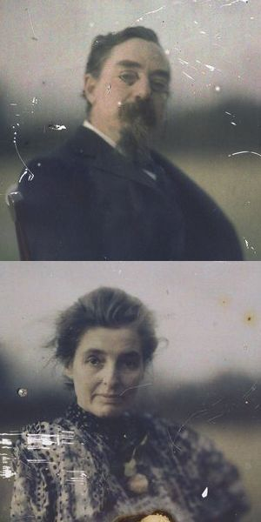

Meetings of the Socialist History Society
Chartism
The SHS has been running a series of evening talks at the Bishopsgate Institute. On Thursday 19th April the speaker was David Goodway on Chartism. His book entitled “London Chartism” was published in 1982.
David began by paying tribute to the Chartist historian Dorothy Thompson who had died in 2011. She had influenced a number of scholars, although not him. Her view on Chartism was that it should be seen its own terms. Interpretations which claimed that the movement was “premature”, were not appropriate.
David went on to talk about eight myths held about Chartism and why he thought that they are wrong. He listed the myths -
- Chartism originated with the London Working Men’s Association.
- The movement was ruined by the split between “physical force” and “moral force” wings.
- There was no support for Chartism in London
O’Connor’s land plan was a reactionary diversion
- O’Connor was a dangerous demagogue
- Chartism was essentially a socialist movement
- Without Chartism there could have been no Labour Party
- Chartism was mainly a movement of the industrial north

In a speech which was well defined and would have been accessible to anyone with little previous knowledge, David dealt with these beliefs, some of which are controversial.
The Charter was first adopted by the LWMA in 1838, but the six points were not new. They had been part of the programme of political radicals since the 18th century, and had already been adopted by the Birmingham Political Union.
There was no real division between the physical and moral force wings – this has been grossly overplayed and the oft cited “peacefully if we may, forcibly if we must”, summed up the unity of the movement on how the Charter was to be achieved.
Chartism had been weak in London in 1839, but by the 1840s it had become a major Chartist centre. Why otherwise would the national committee of the National Chartist Association and the publication of the Northern Star have moved to London from Leeds?
The basis for the land plan was not reactionary – access to the land by promoting small holdings had a major part in the radical tradition in Britain. The Co-operative Land Society set up plots in Hertfordshire and the Cotswolds.
O’Connor was not a fool or demagogue – he was a brilliant orator who believed in independent working class leadership. Tributes to this can be found throughout the 19th century radical press.
Was the movement socialist? Dave believed that by the end of the 1840s remnants of the movement were sympathetic to socialism – Harney and Jones in particular were close associates of Marx and Engels, but this was when the Chartist movement went into decline. For most of its peak time Chartism did not have a socialist objective, and in their old age many former Chartists became active in Liberal politics. This interpretation was discussed in relation to the possible impact of the Owenite socialist movement on Chartism and the fact that Chartists always claimed that their aims were “The Charter and something more”. Perhaps 20th century interpretations of socialism and liberalism have been imposed on the thinking of the Chartist movement.
Was there any continuity with the Labour Party? There was a long gap between the demise of Chartism and the formation of the Labour Party. But it had been the first mass political movement of the working class. Labour leaders had referred back to Chartism. Former Chartists had joined socialist organisations like the Social Democratic Federation in the late 19th century. Some saw labourism as a step back for the movement, from the revolutionary days of Chartism.
The influence of Chartism was nation-wide – large industrial towns like Leeds had over 1,000 members, but even cathedral cities like Salisbury had 100. It was not just a movement of the industrial north. The extent of participation in Wales, Scotland and Ireland was discussed.
The talk attracted a lively discussion among the 30 people attending.
Rethinking Captain Swing
Carl Griffin spoke on the subject of his new book “Rethinking Captain Swing”, which he claimed was the first major book to be published on the subject since Eric Hobsbawm‘s book in 1969. (Captain Swing / Eric Hobsbawn and Charles Rude, Lawrence and Wishart, 1969). The Captain Swing movement which started in Kent, in the countryside north of Dover in 1830, spread across Kent, Sussex, and Hampshire after the trials of machine breakers. It was in protest at the introduction of the threshing machine by farmers, which were seen as responsible for the loss of farm workers’ jobs. The protest took many different forms – threatening letters to farmers and magistrates signed by the mythical “Captain Swing” – Carl showed us some copies of these on his power point display. It also took the form of direct action – burning buildings and destroying machinery. But it had an impact on Parish politics and workhouses came under attack. There were links between protesting farm labourers and radicals in the neighbouring towns. William Cobbett was among the supporters of the Captain Swing movement. As well as farm labourers, small farmers were losing as they could not afford to introduce the threshing machine. So the extent of the movement was wider than formerly believed. Artisans in local towns were often involved in protest activities linked to the Captain Swing movement. Support was voiced for the French Revolution.
In his book Carl gives a graphic account of the geographical extent of the Captain Swing movement, citing instances of protest in villages across the south of England. For anyone who is familiar with the villages of Kent, Sussex and Hampshire today, this makes for impressive reading. In the appendix he lists 800 major incidents between August and December 1830 which were connected to “Swing”. These included arson, attacks on threshing machines and assemblage. Swing was not just about the destruction of threshing machines – it was connected to local issues in the rural community – unemployment, wages and the poor rates. Hence some of the targets could be workhouses and those receiving threatening letters included vicars and magistrates. Often the objective was to put on pressure to resist wage cuts, unjust decisions by the Parish Council in relation to poor relief or the raising of excessive tithes by the Church. It was not just a rural protest – townsmen from market towns such as Lewes, Chichester and Horsham were involved, and although not a political movement, there was a political input to the protest. The Swing movement met with the full force of the state, as it was in those days. Special constables and later the military swarmed the south of England. Punishments were harsh – transportation for life and even the death penalty meted out for what were property offences. Even sending a threatening letter could send you to prison.
However there was also pressure on landlords to reverse poverty wage cuts, or magistrates to cut poor relief. Swing had a lasting effect on the politics of the countryside – threshing machines were in many instances withdrawn, Political unions were set up in many areas which campaigned against the Poor Law Amendment Act introduced in 1834. Under this act poor relief for the able-bodied was only given to those who entered the workhouse.
Having seen the Olympics opening ceremony, which contrasted England’s green and pleasant land with the later dark satanic mills, one is prompted to say that this was an idealist view of the English countryside. The reality being that in the 19th century it was home to riots and burning on a par with any urban area!
The rural war: Captain Swing and the politics of protest by Carl Griffiths is published by Manchester University Press, 9780719086267, £70.

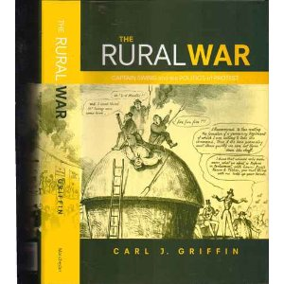

Articles for the next bulletin to –
Barbara Humphries

(mickandbarbara@btopenworld.com)

Back issues of the Labour Heritage bulletin from 2002 are now available on the Labour Heritage web site

http://www.labour-heritage.com/

LABOUR HERITAGE EVENTS THIS AUTUMN
11th Essex Conference on Labour History
Saturday 13th October
10.30-4pm
Labour Hall, Collingwood Road, Witham, Essex
Topics – Levellers in Essex, the 1945-51 Labour Government, world economic crisis and the formation of the labour movement in Southend.
To register £6 – includes lunch

West London Labour Heritage Day
Saturday 24th November 1.30-4.30 Labour Party offices, 367 Chiswick High Rd. W.4
Speakers to be confirmed.
More information on both events available on the Labour Heritage web site

alongside two other GMWUers, George Robertson and Larry Whitty

